**Pond Unit Storyline**

18-20 days

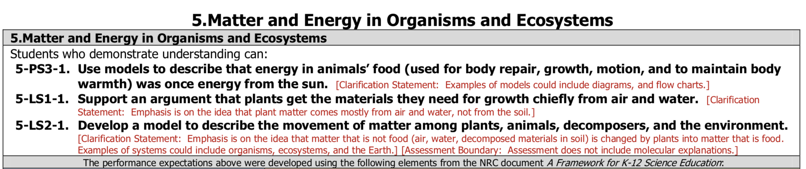



|  |  |  |
| --- | --- | --- |
| Driving Question | Learning Goals | Activities |
| Intro Lesson  2 days  **What are models?**  **What criteria can we use to evaluate models?** | Students develop a definition of models and create a class list of model criteria:  Epistemic learning goals (ELG):   1. As a community we have criteria that we can use to develop, evaluate, and revise models. These are shared norms we all agree to and follow. | Activities   * *Introduction to Modeling*-- In small groups or pairs students review pairs of models and decide which is best and why. They use their ideas about which model is better to develop a list of criteria for good models. * *Reasons*-Define reasons and discuss examples of good quality reasons. * *Evaluate model pairs--* In small groups students will look at various forms of box and arrow models and will decide what makes a good scientific model. The ideas students generate will be used to create the class criteria list. * *Individual criteria list-* Students will generate individual criteria lists and will order them from most to least important. * *Class criteria list*-- As a class, and using the criteria developed by students, we will develop a consensus list of criteria for good models. This list will be posted publicly and used throughout the unit. – * *Expected product*- class criteria for good models |
| Lesson 1  3 days  **Anchoring phenomenon--Why are fish dying?** | Students will figure out that the fish are dying in the pond because they are suffocating.  Epistemic learning goals (ELG):   1. There are often alternative explanations of any one phenomenon. 2. We can use evidence to rule some of these out and narrow the field of possible explanations. 3. We may also need to gather more evidence relating to any models that are left. | Activities   * *Anchoring phenomenon*-- As a class students will watch a video to introduce the pond phenomenon. The video shows a local community problem-- fish are dying in the local pond. A few residents and researchers report on the problem. * *Initial model*-- In small groups, students will make an initial box and arrow model of why they think the fish are dying. Select groups present the models to the class. Models are clustered by type to yield a few different ideas about why the fish are dying. *Expected models*: fish are dying because of the rise in temperature; pollution, or toxins in the water; or they are missing something they need (air, food, etc.). Other models may also come up. * *Evidence*-- In small groups, students will engage with evidence set 1 to rule out some of the models. The evidence set is designed to support the “fish are missing something (specifically air) they need” model, and in particular the evidence will suggest they are missing dissolved air they need to breathe. The evidence set includes:   + E1.1 Temperature - Bar graphs showing the average temperature in a local pond across a time span of several months (showing that temp is never too high or low).   + E1.2 Necropsy report - Vet report showing the health of the fish before they died. Therefore, showing that they are suffocating.   + E1.3 Water quality - Bar graph showing the water quality in a local pond across a time span of several months.   + E1.4 Pond Chlorophyll - Bar graph showing the amount of chlorophyll in a pond over one year.   + E1.5 Dissolved air - Bar graph showing the amount of oxygen needed in water for fish to survive. * *Class discussion, consensus model*-- As a class, students can rule out some of the models and revise the current best model to show that fish are dying from lack of dissolved air. Model can be drawn on the board * *Intro to MEME--* In small groups, students will construct their class consensus model on MEME, which is an online modeling tool. Students will get used to the tools and features in the system. * *Revisit DQ and what we figured out*-- we figured out fish are dying because they don’t have enough dissolved air in the water to breathe. But this raises questions that need more evidence-- where is the air going? Why is it so low? Are fish suffocating because of no air or are they choking on algae (we suspect students may think they are choking). These questions drive Lesson 2. |
| Lesson 2  4 days  **Why are fish suffocating?**  **Are they choking on the algae?**  **Why is the dissolved air low?**  Fish  Algae  Dissolved air  Decomposers  Dead stuff  Not enough for: suffocate!  Die  Die  Eat  Eat | Content learning goals (CLG):   1. Decomposers are tiny organisms that eat dead matter   Things we figured out:   1. Fish die after dead matter & rise in decomposers (link fish death and decomposers) 2. Fish are dying only after algae die 3. Fish are not choking (on algae)   Epistemic learning goals (ELG):   1. Simulations are only useful in some cases: sometimes they open up new questions that must be answered in other ways (using empirical evidence) 2. The assumptions of simulations affect their utility 3. Models can also represent or help identify “black boxes”: components or connections that are needed to complete the mechanism | Activities   * *MEME-* Revise class model to reflect what students know about components and mechanisms. Revise group models to reflect class model. Look at the resource library and how to support a model with evidence. * *Good discussions-* Review and discuss examples of good discussions as a class. * *Evidence*-- Discussion- how to describe evidence. Then in small groups, students will engage with evidence set 2 on MEME. The evidence shows that fish are not choking on the algae, and decomposers are tiny organizers that eat dead matter.   + E2.1 (resource 4): Empirical evidence that fish don’t have algae in gills or body, even though there is algae (live and dead) in the pond.   + E2.2 (resource 5): Analysis of dead matter - pond - the evidence introduces the idea of “microscopic living organisms” [organisms]; shows that as the amount of dead algal mass (in a lab) decreases there are more “microscopic living organisms” on it [opens black box in the simulation-decomposers by linking algae and decomposers]   + E2.3 (resource 6): Analysis of dead matter - park - the evidence shows that as leaves taken from a park decompose there are more “microscopic living organisms” on them - helps with transferring ideas to new contexts * *Evidence discussion-* Why it’s important to describe evidence and how to do so using MEME. * *Modeling-* In small groups students revise their MEME models based on the new evidence (developing models shown on left). They link the evidence (above) to the model. * *Evidence discussion-* How evidence supports the model- students come up with names for the support ratings and rate evidence in MEME. * *Simulation--* In small groups, students will engage with the macro-level simulation (with visible decomposers on the graph): students will learn that fish die after a rise in both dead matter and decomposers. This will link the idea of fish death to decomposers. * *Modeling--* In small groups students revise their MEME models based on the simulation. * *Graphing-* Students will study the features of graphs to be able to read the graphs in MEME. * *Class discussion-- what we figured out*-- Class discussion and documentation of what we figured out and of the scientific principles (CLG). We figured out that decomposers are tiny organisms that eat dead matter. * *Revisit DQ*-- This raises questions: what are these decomposers? What are they doing? Are they related to why the fish are dying? |
| Lesson 3  6 days  **What are decomposers?**  **What are they doing? Are they related to the fish deaths?**  Fish  Algae  Dissolved air  Decomposers  Dead stuff  Not enough for: suffocate!  Die  Die  Eat  Use/breathe  Eat | Content learning goals (CLG) and Things we figure out:   1. Decomposers use up air when eating dead matter (in this case dead algae) 2. Decomposers grow and multiply 3. Decomposers breathe air just like we do (dissolved air in water decreases)   Epistemic learning goals (ELG):   1. Simulations can be used to test hypotheses. 2. Evidence and simulations can be used together to develop and test hypotheses. 3. If simulations do not fit the empirical evidence, their assumptions can be changed. 4. Carefully aligning evidence & simulations with models makes models better. 5. Thoughtful peer critique and uptake of critique makes models better. | Activities   * *Stations-* overview and instructions * *Evidence*-- In small groups in stations, students will engage with evidence set 3, to understand that decomposers grow and multiply and that they use up air when eating dead matter.   + E3.1 Photos & charts- Sorting activity to distinguish decomposers from dead matter. Graph to show dissolved air decreases as dead matter increases. Highlights that decomposers need air to live- they breathe.   + E3.2 Experiment - Study effects of baggie experiment to see how decomposers thrive under different conditions.   + E3.3 *Video-* Shows fruit and vegetables decomposing over time. This supports the learning goal that decomposers are tiny organisms that eat dead matter   + E3.4 Microscopes- Look at decomposers under a microscope.   + E3.5 Video- Producers, consumers, and decomposers.     - [**https://tinyurl.com/y3x3dk3b**](https://tinyurl.com/y3x3dk3b)     - *Hands on--* This can also be done as a class experiment- but it takes a while to see decomposition so it will need to be set up a few weeks in advance before students really understand the connection to the unit. * *Evidence discussion-* discuss what they learned from the evidence, how they should change their model based on new evidence, and what evidence they want to add to the MEME library. * *Evidence discussion-* why evidence is important, how it helps us learn and what to do if evidence contradicts the model. * *Modeling--* In small groups students revise their MEME models based on the new evidence (developing models shown on left). They link the evidence (above) to the model. * *Evidence discussion*- Discuss the question: If there are decomposers in the simulation does this mean there are decomposers in the pond? * *Gallery walk-* Expectations, model preparation, criteria, and comments. * *Mid-point model share & critique-* using a gallery walk format student groups will share their models and receive critique based on the model criteria. * *Revise criteria list-* Students work in small groups and as a class to revise class criteria list. * *Modeling-* In small groups students revise their MEME models based on the comments from the gallery walk. * *Class discussion- what we figured out*- Class discussion and documentation of what we figured out and of scientific principles (CLG). We know decomposers are rising because there is a lot of dead algae which is their food. This allows more decomposers to eat and grow and reproduce. * *Revisit DQ--* This raises questions: why are there more algae? What is causing the increase in algae? |
| Lesson 4  4 days  **Why are there more algae?**  **Where are the nutrients coming from?**  Fish  Algae  Dissolved air  Decomposers  Dead stuff  Not enough for: suffocate!  Die  Die  Eat  Use/breathe  Nutrients  Eat  Fertilizer  Eaten  Runoff  (increase)  Use/breathe  Sunlight  Use | Things we figured out:   1. Algae are tiny plants that live in water. 2. Fertilizer has nutrients 3. Fertilizer from lawns can get to lakes/ponds/sea after rain events (via groundwater)   Content learning goals (CLG):   1. All plants (including algae) need light, water, air, and nutrients to grow and survive 2. Matter moves through a system- plants get their needs from water, air, and sun; fish eat plants; dead fish and plants are eaten by decomposers. 3. Everything starts from the sun, which the plants need.   Epistemic learning goals (ELG):   1. Simulations can simplify, and sometimes obscure, certain aspects of the phenomenon (for example, water is all around the algae so we cannot see that they need water). 2. Students may know that plants make oxygen, but this is not in the simulation. The simulation simplifies the phenomenon by simulating what plants need, and not what plants make. 3. Models are not a single thing, there may be parts of models that are better supported than others. 4. Some parts of the model we may be certain about and others we may be less certain (due to inconclusive evidence) 5. Ideally, our models will have evidence to support all the parts, and we acknowledge where there are parts with little or no evidence. | Activities   * *Decomposers*- Review what students know about decomposers and what they still don’t know. * *Simulation-* In small groups, students will explore the macro-2 simulation that shows relationships between algae, light, air, and nutrients (there is always air in the system so you cannot change dissolved air level). * *Discussion-* What did they learn from the simulation? * *Evidence-* In small groups, students will engage with evidence set 4: show that algae are tiny plant organisms, and that algae need light, water, air and nutrients to survive.   + E4.1 Sunlight at Passion Pond- Graph showing hours of sunlight each month.   + E4.2 Plants in sunlight- Report to show that plants need sunlight to make their own food.   + E4.3 A. Fertilizer and Plants- Report to show the effects of fertilizer on grass. B. Fertilizer and algae- Report to show the effects of fertilizer on algae.   + E4.4 Air in aquariums- Pictures to show what happens to plants in a vacuum.   + E 4.5 Fertilizer labels- Report to show ingredients in fertilizer.   + E4.6 Lake Erie Algal Blooms- Report to show the pond before and after rain, showing that that fertilizer gets into water from lawns. * *MEME-* revise model on MEME based on evidence, simulations, and class criteria. * *Consensus model*-- as a class share students’ models and develop a consensus model that can be publicly shared and captures our understanding. Discuss which parts of this model are supported by evidence, which parts we are certain about (because of lots of supporting evidence) and which we are less sure about; what other questions do we still have. * *Group presentations-* focus groups present their models. * *Post-test-* students work on the unit post-test. * *Class discussion-- what we figured out*-- Class discussion and documentation of what we figured out and of scientific principles (CLG). We know plants need light, nutrients, air (or dissolved air), and water. * *Revisit DQ*-- This raises questions about how humans impact the environment in terms of using fertilizer. Where else does this happen? Is this common? Can this be solved? |
| Lesson 5  2 days  **Why are there more algae?**  **Where are the nutrients coming from?**  Fish  Algae  Dissolved air  Decomposers  Dead stuff  Not enough for: suffocate!  Die  Die  Eat  Use/breathe  Nutrients  Eat  Fertilizer  Eaten  Runoff  (increase)  Use/breathe  Sunlight  Use | Things we figured out:   1. Algae are tiny plants that live in water. 2. Fertilizer has nutrients 3. Fertilizer from lawns can get to lakes/ponds/sea after rain events (via groundwater)   Content learning goals (CLG):   1. All plants (including algae) need light, water, air, and nutrients to grow and survive 2. Matter moves through a system- plants get their needs from water, air, and sun; fish eat plants; dead fish and plants are eaten by decomposers.   Epistemic learning goals (ELG):   1. Good oral arguments involve give and take, sharing reasons, making sure you understand, everyone being heard, and respectful disagreement. | Activities   * *Class discussion-* If a simulation shows something is happening, does this mean it is happening in real life e.g. in a pond? * *Performance assessment-* apply concepts learned in the unit to a pond scenario * *Argument game-* Students are shown various opinions and they need to decide which ones they agree with.This taps into how students think about the nature of evidence and simulations, the validity of models, importance of criteria, and content. |
| Lesson 6  2 days  **Where else does this happen?**  **How can we solve this?** | Things we figured out:   1. Identify strategies to solve this problem, like reducing fertilizer and airing the pond. 2. This phenomenon also occurs in other locations   Content learning goals (CLG):  We can use science ideas to solve problems and protect the Earth’s environment.  Epistemic learning goals (ELG):   1. Models can be generalized from one phenomenon (e.g. the pond) to others (ocean, reefs, other ponds). We can develop a model that is more abstract and can fit/explain many phenomena. | Activities   * *Video evidence--* In small groups, students will engage with evidence set 6 about where else this phenomenon happens: students will learn that eutrophication occurs in other locations. This lesson will also reinforce the idea of matter movement and food webs * *News articles-* In pairs, students will read articles about where/how else this   happens (coral reefs in Oman, Florida red tide, Arctic blooms).   * *Jigsaw-* Students jigsaw in their tables to share evidence with peers. * *Summary discussion*– Briefly discuss general things that we got from the   articles: this happens in a lot of places and is harmful in a few different ways   * *Solution challenge*– In small groups, students will work together to come up with a solution. * *Sharing solutions*- Groups share their solutions. Students discuss which is   best, or pros/cons of different solutions-- |

Full standards:

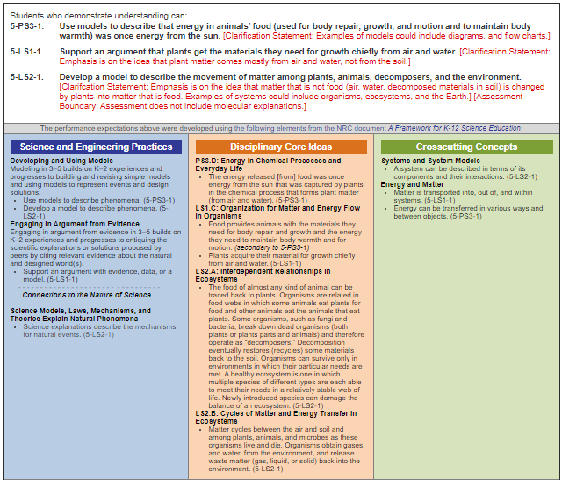

<https://www.nextgenscience.org/topic-arrangement/5matter-and-energy-organisms-and-ecosystems>

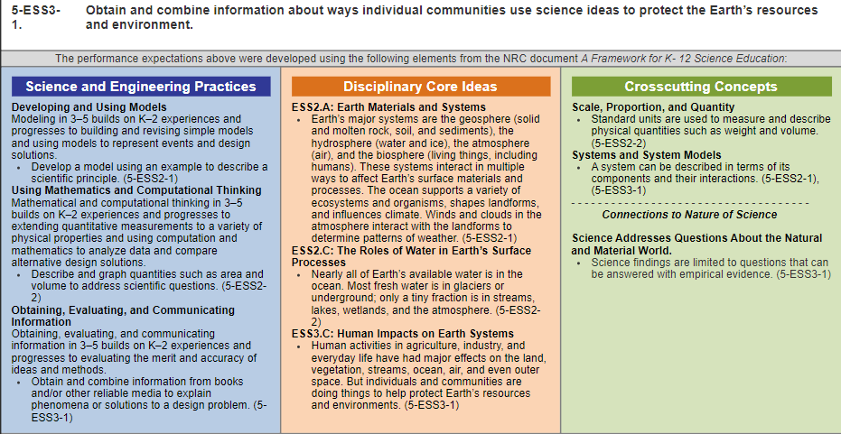

<https://www.nextgenscience.org/topic-arrangement/5earth%E2%80%99s-systems>